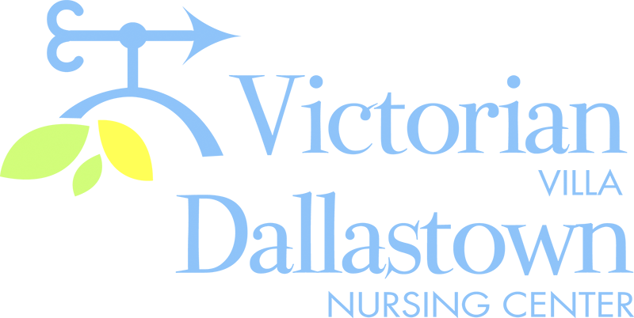
Upcoming Special Events
Group Activities
You will notice that there are some changes
to the Activity Calendar, as we are modifying the number of groups held through the month of April. Please remember, this is temporary and our groups will resume as normal, as soon as is safe for everyone. Thank you for your patience and understanding.

Update
Our Pie Bake-Off was held on March 26th.

There were 4 entries: Lemon No-Bake, Pumpkin-Raisin No-Bake, Peanut Butter Pie and a Peppermint Patty Pie.
The winner was the Lemon Pie submitted by the Villa Ladies!
^{Congratulations!}

April 10th
Good Friday Service
Join us in the Villa Activity Room for a special Good Friday Service presented by Dave Jacoby.
The service will begin at 2:00pm.

April 14th
We will celebrate April Birthdays on Tuesday, April 14th in both the DNC and the Villa. 2:00pm in the DNC and 2:30pm in the Villa.
DNC
- Ron C.-4/1
Villa
- Joan L.-4/3
- Leona H.-4/5
- Hazel W.-4/9
- Ed W.-4/17

You can email your loved one anytime at the following email address:
dbixler@dallastownnursingcenter.com
Please feel free to direct any questions or concerns to the appropriate departments:
*Dean Boyer, Administrator *Georgia Nickel, PCH Administrator
*Linda Jermyn, Director of Wellness *Stacie Achenbach, Food Service Director
*April Snyder, Environmental Services *Diana Bixler, Activity Director
*Woody Harrison, Maintenance DNC-*Sue Sprague, DON *Steph Freed, LPN, IC

