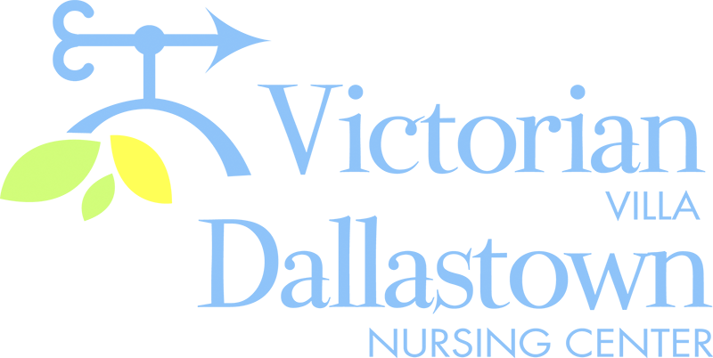
Upcoming Special Events
“Elvis Week”
We will be celebrating “The King of Rock & Roll”, the week of August 10th-14th.
We will “kick off” the week with Elvis music, and end the week with “Pink Cadillac Bingo”.
Check your calendars for all the Elvis activities planned for the week.

Activities
Even though the county has moved into the “Green Phase” of the pandemic, we still have restrictions in place.
Therefore, we still cannot go on trips or have visitors/entertainers in the facility. However, we are almost back to normal with in-house scheduled group activities. Thank you for your patience and understanding. Remember, we are all in this together.

Armchair Travel
August 18th
Our travels will be closer to home this month-Lancaster PA.!
We will enjoy an Armchair travel video about “Amish Country”, and follow up with some good old-fashioned “PA Dutch” foods.

Birthday Celebration
We will celebrate DNC Birthdays on 8/18 at 2:00pm.

Butch M.-8/9
Ottalie G.-8/29
Rafael Y.-8/29
Doris E.-8/30

(there are no birthdays, in the Villa, this month)

You can email your loved one anytime at the following email address:
dbixler@dallastownnursingcenter.com
Please feel free to direct any questions or concerns to the appropriate departments:
*Dean Boyer, Administrator *Georgia Nickel, PCH Administrator
*Melissa Gingher, Director of Wellness
*Stacie Achenbach, Food Service Director *April Snyder, Environmental Services
*Diana Bixler, Activity Director *Woody Harrison, Maintenance
DNC-*Sue Sprague, DON *Steph Freed, LPN, IC

