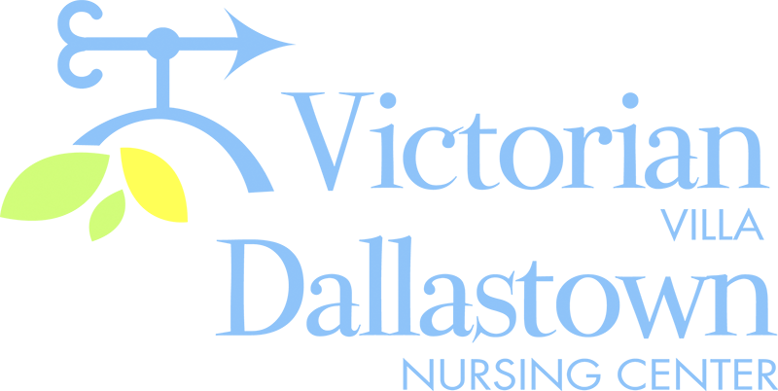
Upcoming Special Events
Friday June 19th
Following our 2:00pm Friday Bingo session, we will celebrate Father’s Day by having Root-Beer Floats.

As soon as restrictions are lifted, regarding travel, we will go on a Men’s Breakfast or Lunch Trip.

Activities
Even though the county has moved into the “Yellow Phase” of the pandemic, there are still restrictions in place.
Therefore, we still cannot go on trips or have visitors/entertainers in the facility. However, we are almost back to normal with in-house scheduled group activities. Thank you for your patience and understanding. Remember, we are all in this together.

Holiday Picnic
June 26th
A picnic is planned for June 26th in both the Villa and The DNC. Weather permitting, we will hold the picnics in the Villa parking lot and the DNC deck.
This picnic is for residents only.

June 16th & 17th
We will celebrate Villa Birthdays on 6/16 at 2:00pm. Dave Jacoby will perform.
We will celebrate DNC Birthdays on 6/17 at 2:00pm. An Auction will follow the party.
Villa-Treva M.-6/11
Marian B.-6/20
Rodger S.-6/24
DNC- Mabel W.-6/17
Hilda A.-6/27

You can email your loved one anytime at the following email address:
dbixler@dallastownnursingcenter.com
Please feel free to direct any questions or concerns to the appropriate departments:
*Dean Boyer, Administrator *Georgia Nickel, PCH Administrator
*Stacie Achenbach, Food Service Director *April Snyder, Environmental Services
*Diana Bixler, Activity Director *Woody Harrison, Maintenance
DNC-*Sue Sprague, DON *Steph Freed, LPN, IC

