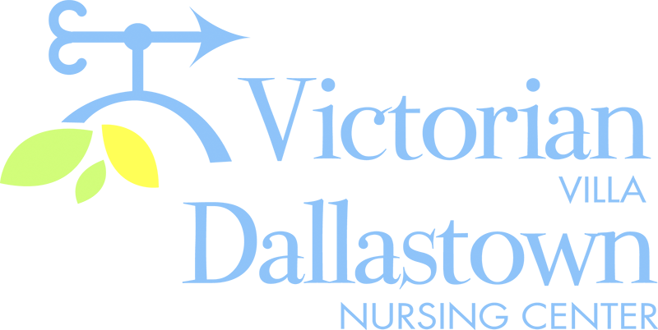
Upcoming Special Events
December 10th December 11th
We will be celebrating The residents of the
December birthdays on DNC and The Villa
12/10 at 2:00pm. will present a
Pam & Don Geiselman “Live Nativity Scene”.
are scheduled to perform The performance will
in the Villa Activity Room. take place at 7:00pm
DNC-*Pat S.-12/8 in the Villa Activity
Villa-*Lois M.-12/12, Libby S.-12.22 Room. Family and
*Ron L.-12/24, Ruth B.-12/28 friends are welcome.
December 15th December 19th
Please join us for our Holiday The Christmas Party & Gift
Drop-In on 12/15 , from Giving for the residents, will
1:00-3:30pm in the Activity Room. be held on 12/19 . DNC will
Family and friends are welcome to start at 1:45pm, The Villa will
Join us for seasonal refreshments and fun! begin at 2:30pm.
Latest News
You can email your loved one anytime at the following email address:
dbixler@dallastownnursingcenter.com

Please feel free to direct any questions or concerns to the appropriate departments:
*Georgia Nickel, PCH Administrator *Linda Jermyn, Director of Wellness
*Stacie Achenbach, Food Service Director *April Snyder, Environmental Services
*Diana Bixler, Activity Director *Woody Harrison, Maintenance
DNC-*Sue Sprague, DON *Steph Freed, LPN, IC

