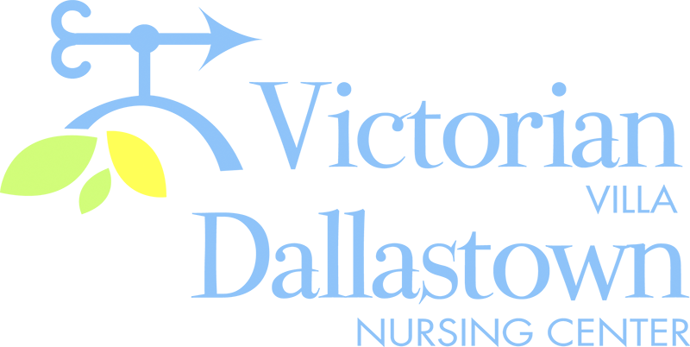
Upcoming Special Events
February 11th February 12th
The event “Valentine’s The staff from River Rock
For Kids at Heart” will be Academy will host a
presented and broadcast Valentine’s Day Celebration
by radio station “WGTY” on 2/12 at 3:00pm. Seasonal
at 2:00pm in the Villa refreshments and crafts will
Activity Room. The be offered.
program will involve
food, games and fun!
February 14th February 18th
Sandy Heisey will play the February Birthday Party
piano and sing love songs to us 2:00pm in the Villa
on Valentine’s Day! The party will Activity Room. Lauren Knatz begin at 2:00pm. Light refreshments scheduled to perform.
be will be offered. Also-We will Mary Z.-2/2 Catherine G.-2/3 “crown” a King & Queen of Hearts! Dwight M.-2/13 Theda K.-2/18
Delph M.-2/25 Treva D.-2/29
Latest News
You can email your loved one anytime at the following email address:
dbixler@dallastownnursingcenter.com

Please feel free to direct any questions or concerns to the appropriate departments:
*Georgia Nickel, PCH Administrator *Linda Jermyn, Director of Wellness
*Stacie Achenbach, Food Service Director *April Snyder, Environmental Services
*Diana Bixler, Activity Director *Woody Harrison, Maintenance
DNC-*Sue Sprague, DON *Steph Freed, LPN, IC

