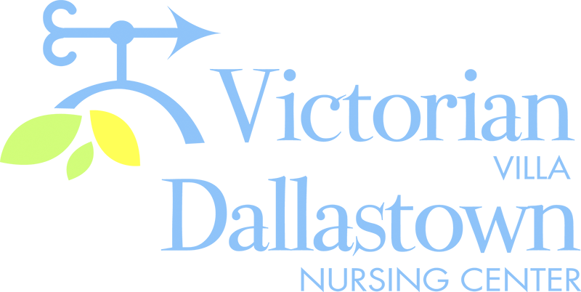
Upcoming Special Events
January 14th January 18th
We will be celebrating We will be warming up this
January birthdays on winter during a “Hot Cocoa
1/14 at 2:00pm. Skip & Marshmallow” Social on
Morton will be our Saturday , January 18th at
entertainer. The party 2:00pm in the Activity Room.
will be held in the We will also have hot tea
Villa Activity Room. available.
Villa birthdays: Doris G. 1/11
Jeanne S. 1/29
.
January 23rd January 30th
Join us in welcoming our If you know your music, join
newest members at a Welcome us on 1/30 at 2:00pm for Tea. We will serve hot and cold “Musical Memories”. Bob beverages along with pastries Bracilano plays his keyboard
in the Villa Dining Room at 2:00pm. and we guess what song it is.

Latest News
You can email your loved one anytime at the following email address:
dbixler@dallastownnursingcenter.com

Please feel free to direct any questions or concerns to the appropriate departments:
*Georgia Nickel, PCH Administrator *Linda Jermyn, Director of Wellness
*Stacie Achenbach, Food Service Director *April Snyder, Environmental Services
*Diana Bixler, Activity Director *Woody Harrison, Maintenance
DNC-*Sue Sprague, DON *Steph Freed, LPN, IC

