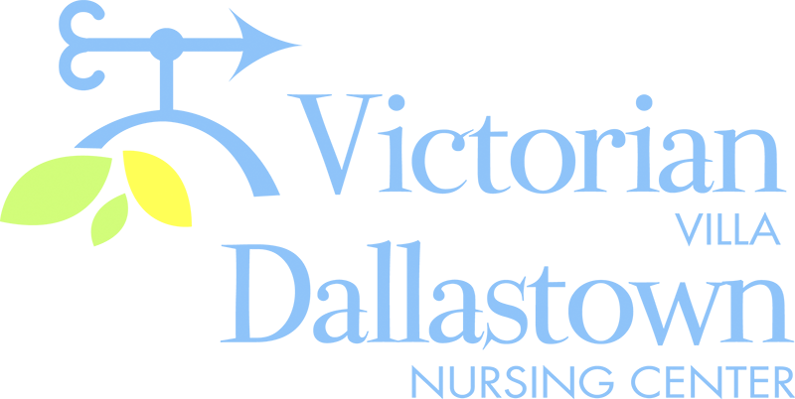
Upcoming Special Events
November 12th November 10th
We will be celebrating “Sweet Life” will perform
November birthdays on 11/12 a special patriotic service for
at 2:00pm. Dominic Cico our veterans. Join us at 2:00pm
is scheduled to perform. in the Villa Activity Room.
*Ila Faye-11/10, Donald G.-11/10 Lois K.-11/20, Earl S.-11/22, Cloyd H.-11/27
November 11th November 27th
Veteran’s Day 2019 Jimmy Edwards is scheduled
Evelyn Selby will provide to perform at 2:00pm in the
patriotic music as we honor our Villa Activity Room.
heroes at 2:00pm in the Villa Join us for music and fun! Activity Room. Light refreshments to follow the service.
Latest News
You can email your loved one anytime at the following email address:
dbixler@dallastownnursingcenter.com

Please feel free to direct any questions or concerns to the appropriate departments:
*Georgia Nickel, PCH Administrator *Linda Jermyn, Director of Wellness
*Stacie Achenbach, Food Service Director *April Snyder, Environmental Services
*Diana Bixler, Activity Director *Woody Harrison, Maintenance
DNC-*Sue Sprague, DON *Steph Freed, LPN, IC

