

**The Villa Times**

**January 2021**

Dallastown Nursing Center

623 East Main Street

Dallastown, Pa 17313

(717) 244-2295

You can email your loved one anytime at the following

email address: dbixler@dallastownnursingcenter.com

***January Birthday Celebration***

***Tuesday, January 12th***

***2:00pm***

***Birthdays:***

***Margaret S.-1/18***



***.***

***PJ Party!***

***Wednesday January 27th***

***6:45pm***



***Saying Hello to 2021!***

***As we usher in a New Year, let us strive to find positivity and hope in each coming day!***

***We pray that each day is brimming with promises of our country returning to a better normal!***

***We are saying good-bye to a very challenging year. We lost some friends and feel we have lost some freedom, but we know God will see us into a better New Year! A year we can resume going on trips, having entertainers perform for us and have our family and friends come INSIDE and visit with us!***

***May God Continue to Bless Us All!***



**Attention**

**Beginning this month, on Wednesdays and Fridays, Bingo will begin at 1:45pm.**

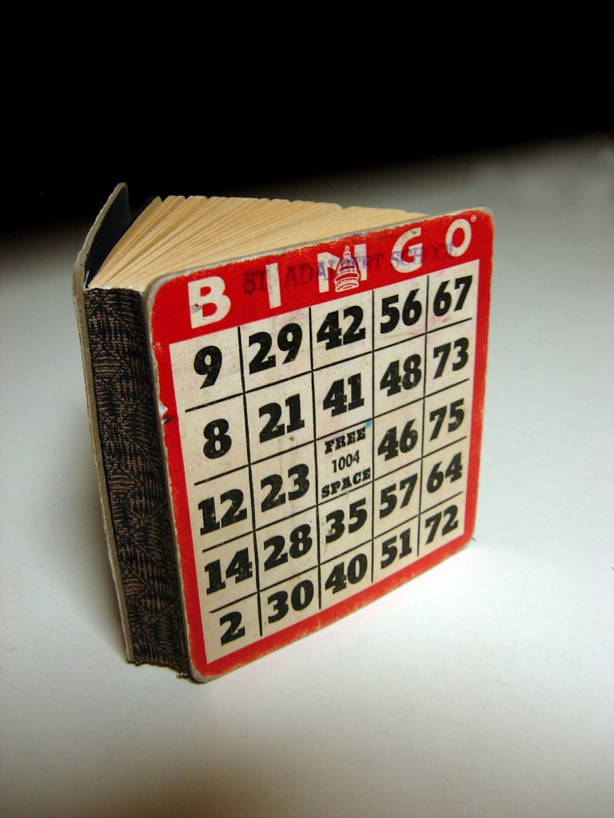

|  |
| --- |
| ***Resident***  ***Roundtable***  ***Tuesday January 5th***  ***At 2:00pm***  ***Activity Room*** |



**Please feel free to direct any questions or**

**concerns to the appropriate departments:**

Dean Boyer-Administrator

Georgia Nickel-Personal Care Administrator

Jesus Guerra-Director of Wellness

Andrea Joines- Food Service Director

April Snyder- Environmental Services

Diana Bixler- Activity Director

Woody Harrison- Maintenance