**`**

**Zeke & Callum**

**Join us for their string performance on Friday, April 5th at 10:45 in the Activity Room!**



**Please feel free to direct any questions or concerns to the appropriate departments:**

Mark Atwood-Administrator

Debra McCue-Personal Care Administrator

Angie Zagroba-Resident Care Coordinator

April Snyder-Food Service Director& Environmental Services

Diana Bixler- Activity Director

David Zimmerman-Maintenance

Steph Freed-LPN, Infection Control

Alysha Bauer-LPN, SS, Staff Development

**Green Thumb Garden Club**

**The group will provide horticulture therapy on Wednesday, April 10th at 10:30am**



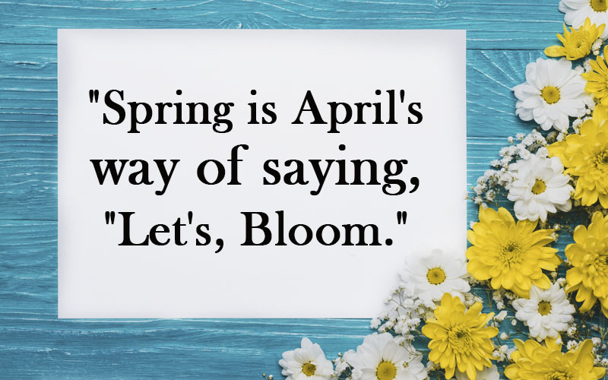

**The Victorian Villa**

**April**

***2024***

621 E. Main St.

Dallastown, PA 17313

(717)-244-9722

You can email your loved one anytime at:

dbixler@dallastownnursingcenter.com

**April**

**Birthdays**

**Fae R. 4/16(DNC)**

**We will celebrate birthdays on Tuesday, April 16th.**

**Join us at 2:00pm in the Villa Dining Room.**



Resident Roundtable

Tuesday, April 2nd at

2:00pm in the Villa Activity Room

Ice Cream will be served afterwards.