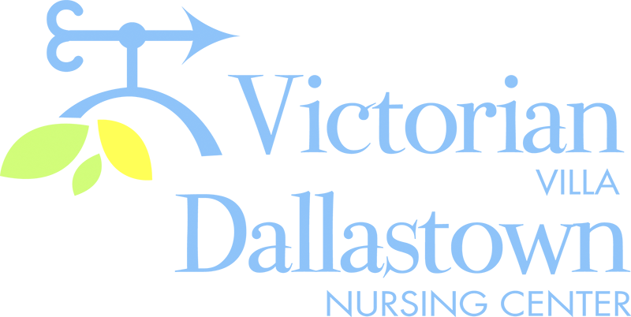
Upcoming Special Events
September 10th September 16th-21st
We will be celebrating Fair Week
September birthdays on 9/10 Check your calendars for
at 7:00pm. Jimmy Edwards is special fair-related events
scheduled to perform. Throughout the week!

*George C. on 9/2 *Charlotte B. on 9/18

September 20th September 24th
Join us for our Annual Outdoor A Campfire Sing-a-Long
Picnic! It will be part of our Fair will be held in the Activity
Week celebration! It will be held Room at 7:00pm. Dave,
In the parking lot at 11:30am. Winnie & Scott will lead us
(weather permitting) in song and worship!

Latest News
You can email your loved one anytime at the following email address:
dbixler@dallastownnursingcenter.com

Please feel free to direct any questions or concerns to the appropriate departments:
*Georgia Nickel, PCH Administrator *Linda Jermyn, Director of Wellness
*Stacie Achenbach, Food Service Director *April Snyder, Environmental Services
*Diana Bixler, Activity Director *Woody Harrison, Maintenance
*Steph Freed, LPN, IC

